Architecture Design
Financial Analytics

Revision Number: 1.0
Last Date of Revision:

Rohan Bagde

Document Version Control

Date Issued | Version | Description | Author
30th December 2021 | 1.0 | First Version Complete LLD | Rohan Bagde

Contents
Document Version Control 2
1. Introduction 4
1.1 What is Architecture Design Document? 4
1.2 Scope 4
2. Architecture 5
3. Deployment Description 8
3.1 Deployment options in Tableau 8
3.2 Single Node Architecture 9
3.3) 3 Node Architecture 10
3.4) 5 Node Architecture 11

1. Introduction
1.1 What is Architecture Design Document?
Any software needs the architectural design to represents the design of software. IEEE defines architectural design as “the process of defining a collection of hardware and software components and their interfaces to establish the framework for the development of a computer system.” The software that is built for computer-based systems can exhibit one of these many architectures.

Each style will describe a system category that consists of:
- A set of components (e.g.: a database, computational modules) that will perform a function required by the system.
- The set of connectors will help in coordination, communication, and cooperation between the components.
- Conditions that how components can be integrated to form the system.
- Semantic models that help the designer to understand the overall properties of the system.

1.2 Scope
Architecture Design Document (ADD) is an architecture design process that follows a step-by-step refinement process. The process can be used for designing data structures, required software architecture, source code and ultimately, performance algorithms. Overall, the design principles may be defined during requirement analysis and then refined during architectural design work.

2. Architecture

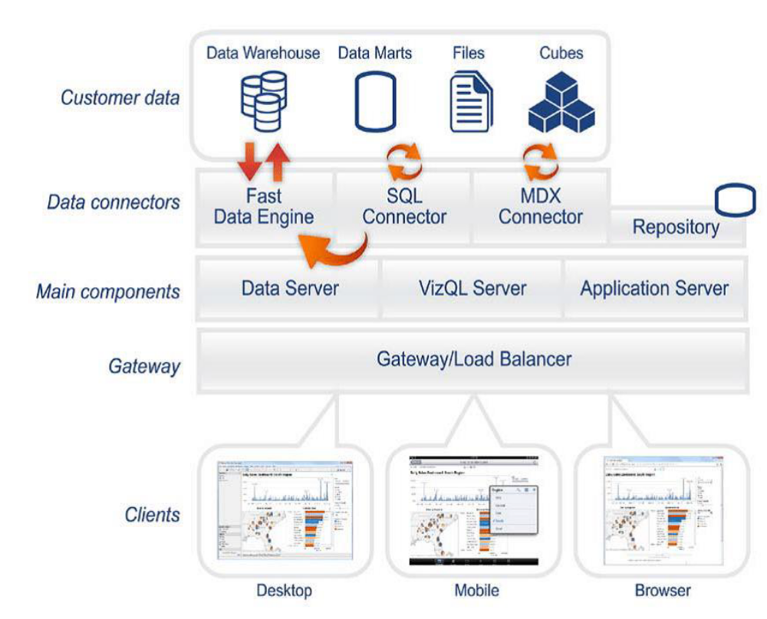

Tableau Server Architecture
Tableau has a highly scalable, n-tier client-server architecture that serves mobile clients, web clients and desktop-installed software. Tableau Server architecture supports fast and flexible deployments.

The following diagram shows Tableau Server’s architecture:
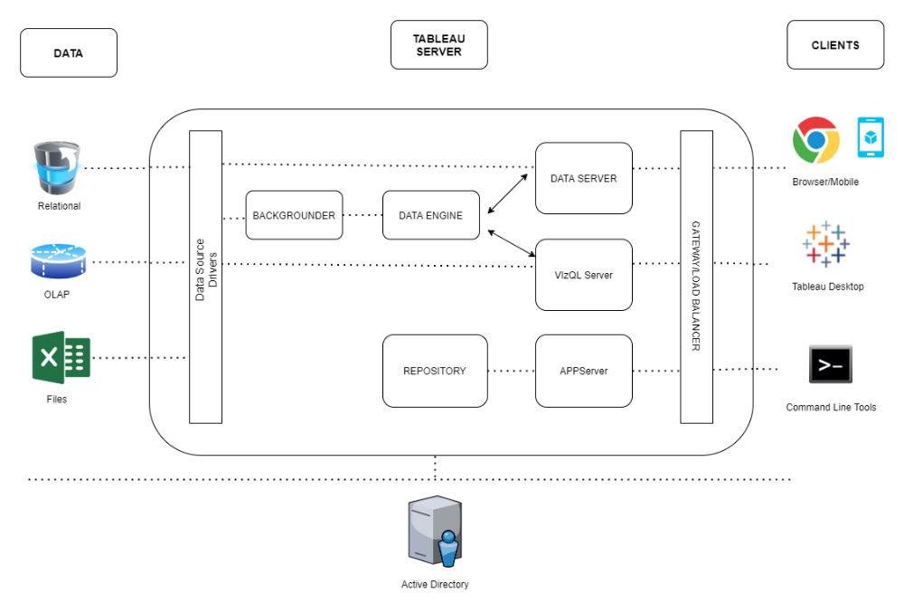
Tableau Server is internally managed by the multiple server processes.
1)Load Balancer: -
It acts as an Entry gate to the Tableau Server and also balances the load to the Server if multiple Processes are configured.

2) Application Server: -
Application Server processes (wgserver.exe) handle browsing and permissions for the Tableau Server web and mobile interfaces. When a user opens a view in a client device, that user starts a session on Tableau Server. This means that an Application Server thread starts and checks the permissions for that user and that view.
3) Repository: -
Tableau Server Repository is a PostgreSQL database that stores server data. This data includes information about Tableau Server users, groups and group assignments, permissions, projects, data sources, and extract metadata and refresh information.

4) VIZQL Server: -
Once a view is opened, the client sends a request to the VizQL process (vizqlserver.exe). The VizQL process then sends queries directly to the data source, returning a result set that is rendered as images and presented to the user. Each VizQL Server has its own cache that can be shared across multiple users

5) Data Engine: -
It Stores data extracts and answers queries.

6) Backgrounder: -
The backgrounder Executes server tasks which includes refreshes scheduled extracts, tasks initiated from tabcmd and manages other background tasks.

7) Data Server: -
Data Server Manages connections to Tableau Server data sources
It also maintains metadata from Tableau Desktop, such as calculations, definitions, and groups.
8) Tableau Communication Flow
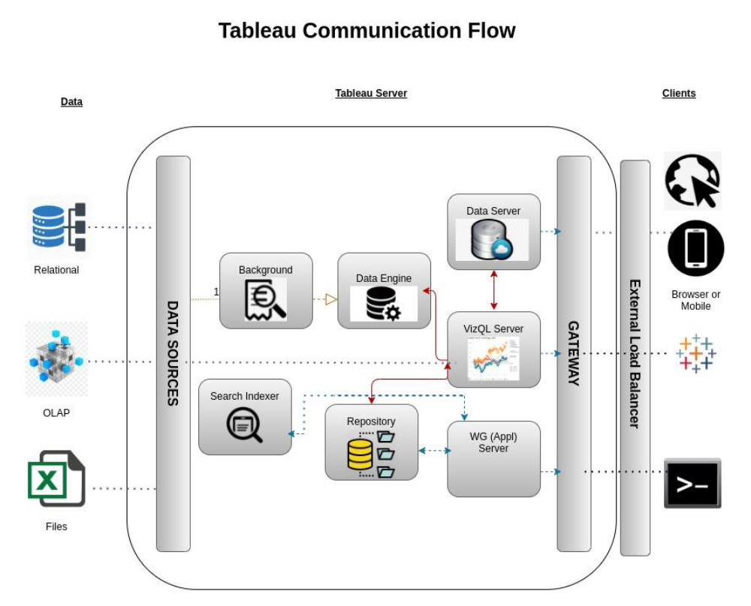

3. Deployment Description

3.1 Deployment options in Tableau
Tableau’s analytics platform offers three different deployment options depending on your environment and needs. The below graphic shows each option at a glance:
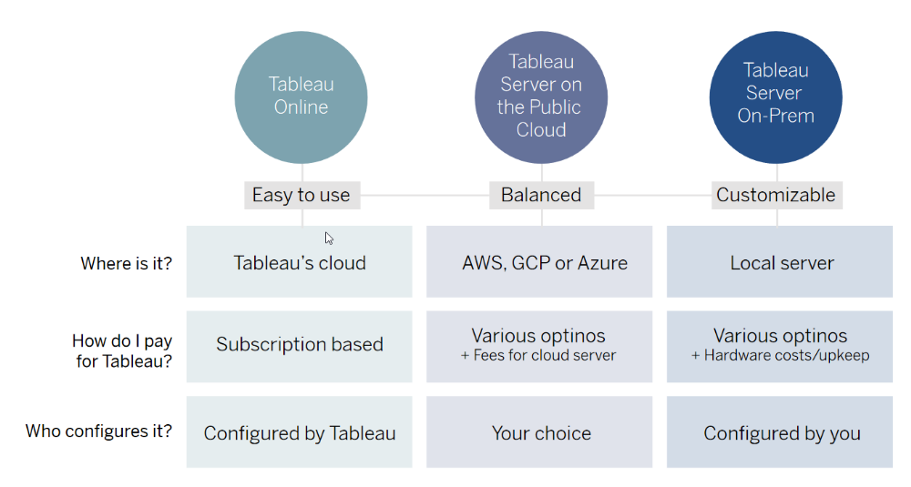
1. Tableau Online Get up and running quickly with no hardware required. Tableau Online is fully hosted by Tableau so all upgrades and maintenance are automatically managed for you.
2. Tableau Server deployed on public cloud: Leverage the flexibility and scalability of cloud infrastructure without giving up control. Deploy to Amazon Web Services, Google Cloud Platform, or Microsoft Azure infrastructure to quickly get started with Tableau Server (on your choice of Windows or Linux). Bring your own license or purchase on your preferred marketplace.
3. Tableau Server deployed on-premises: Manage and scale your own hardware and software (whether Windows or Linux) as needed. Customize your deployment as you see fit.

3.2 Single Node Architecture
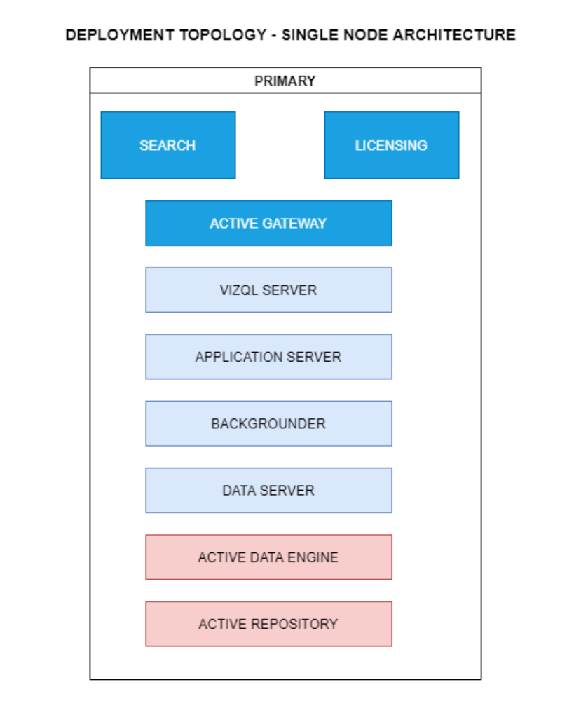
This architecture is a single node architecture. This is the simplest deployment topology.

3.3) 3 Node Architecture
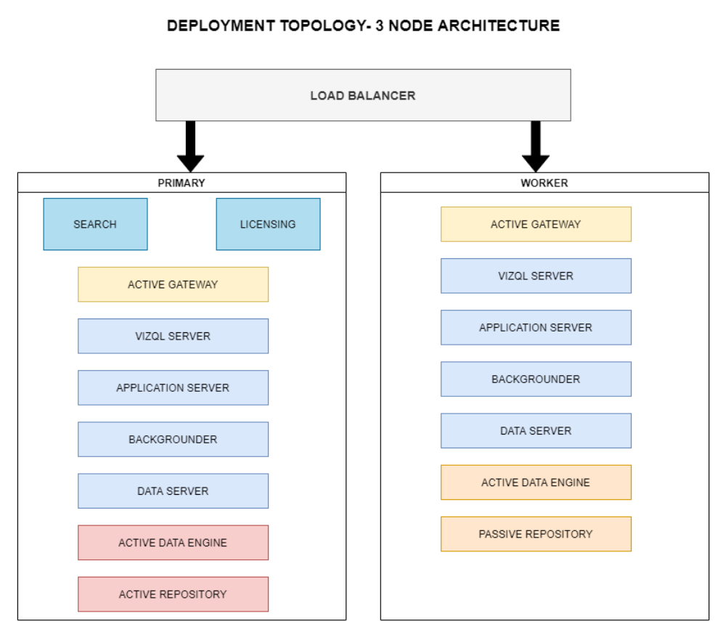
This architecture is a 3 Node Architecture which is more capable to handle concurrent requests.
If we need failover or high availability, or want a second instance of the repository, we must install Tableau Server on a cluster of at least three computers. In a cluster that includes at least three nodes, you can configure two instances of the repository, which gives our cluster failover capability.

3.4) 5 Node Architecture
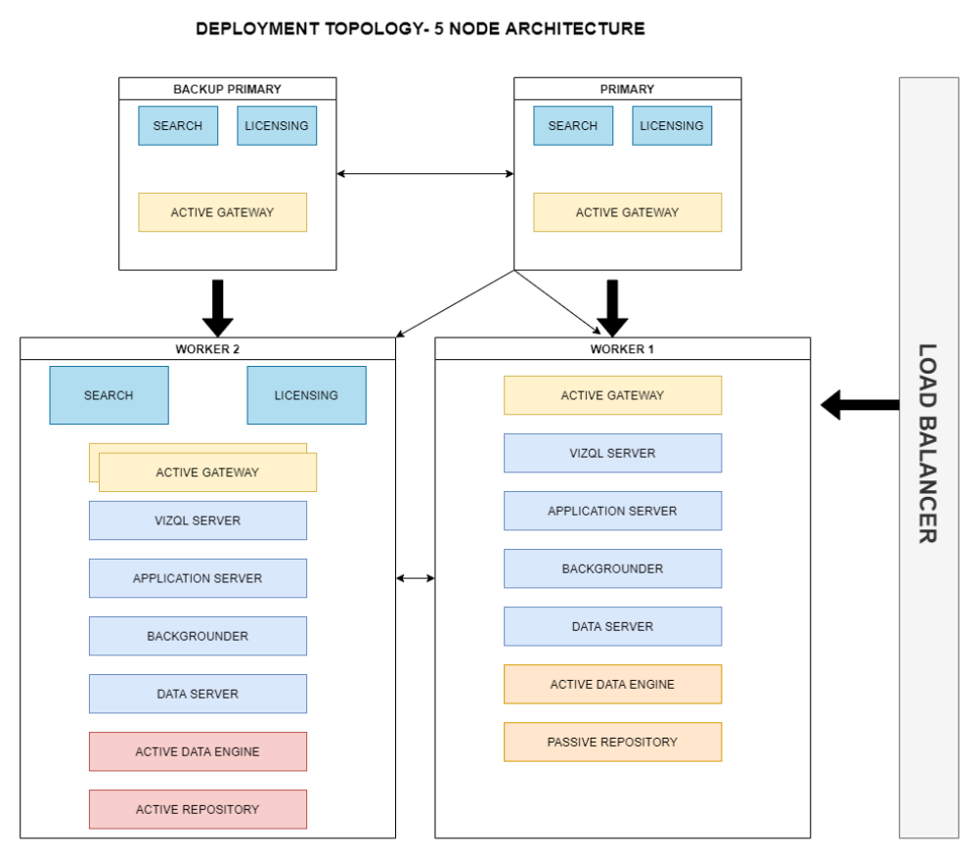
When we install Tableau Server on a Five-node cluster, we can install server processes on one or both nodes. A five-node cluster can improve the performance of Tableau Server, because the work is spread across multiple machines.
Note the following about five-node clusters:
- A five-node cluster does not provide failover or support for high availability.
- You can't install more than one instance of the repository on a two-node cluster, and the repository must be on the initial node.

